sudo apt update

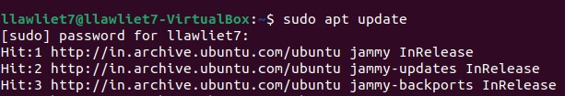

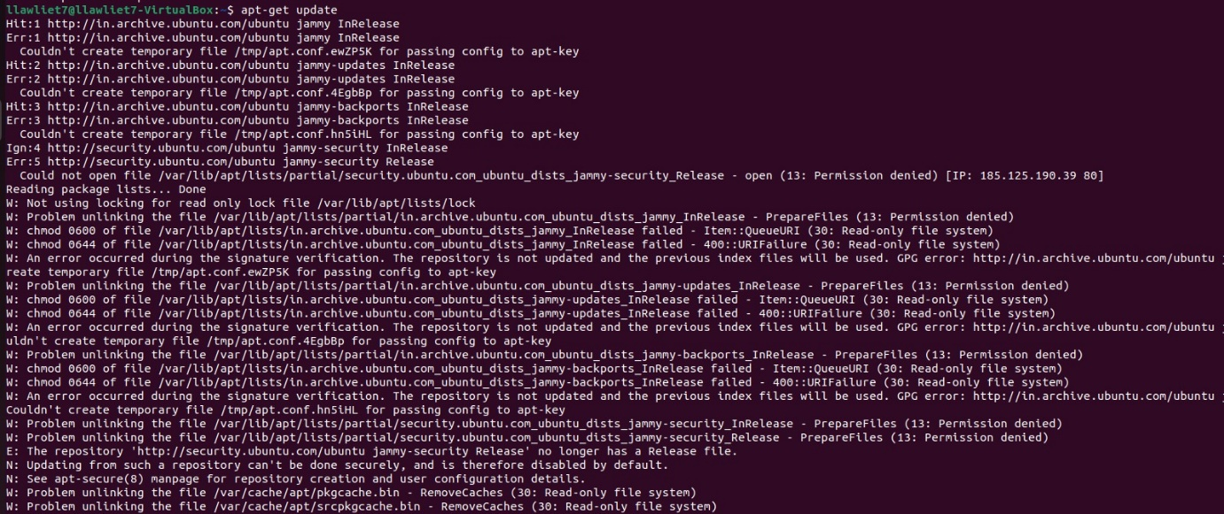

sudo apt upgrade

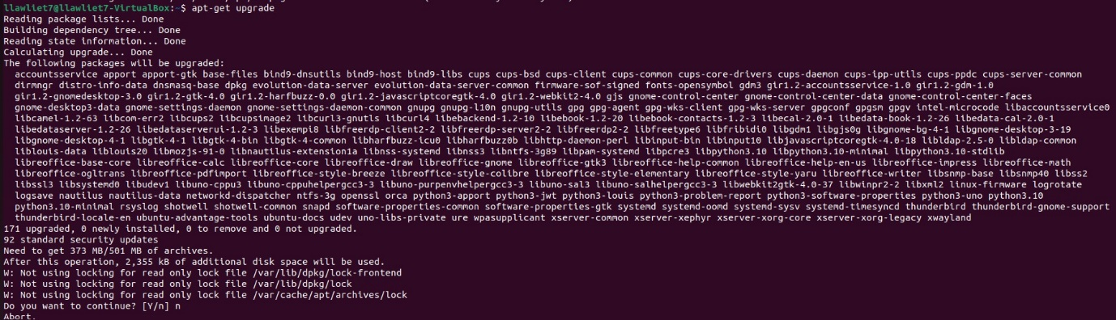

ls

C:\Users\Lawliet7\OneDrive\Pictures\Screenshot 2022-07-31 195024.jpg

sudo apt-get install

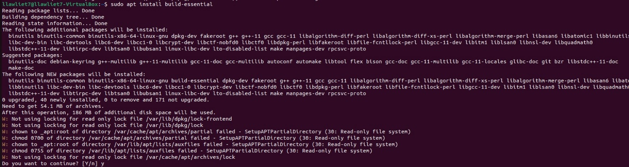

pwd

C:\Users\Lawliet7\OneDrive\Pictures\Screenshot 2022-07-31 195852.jpg

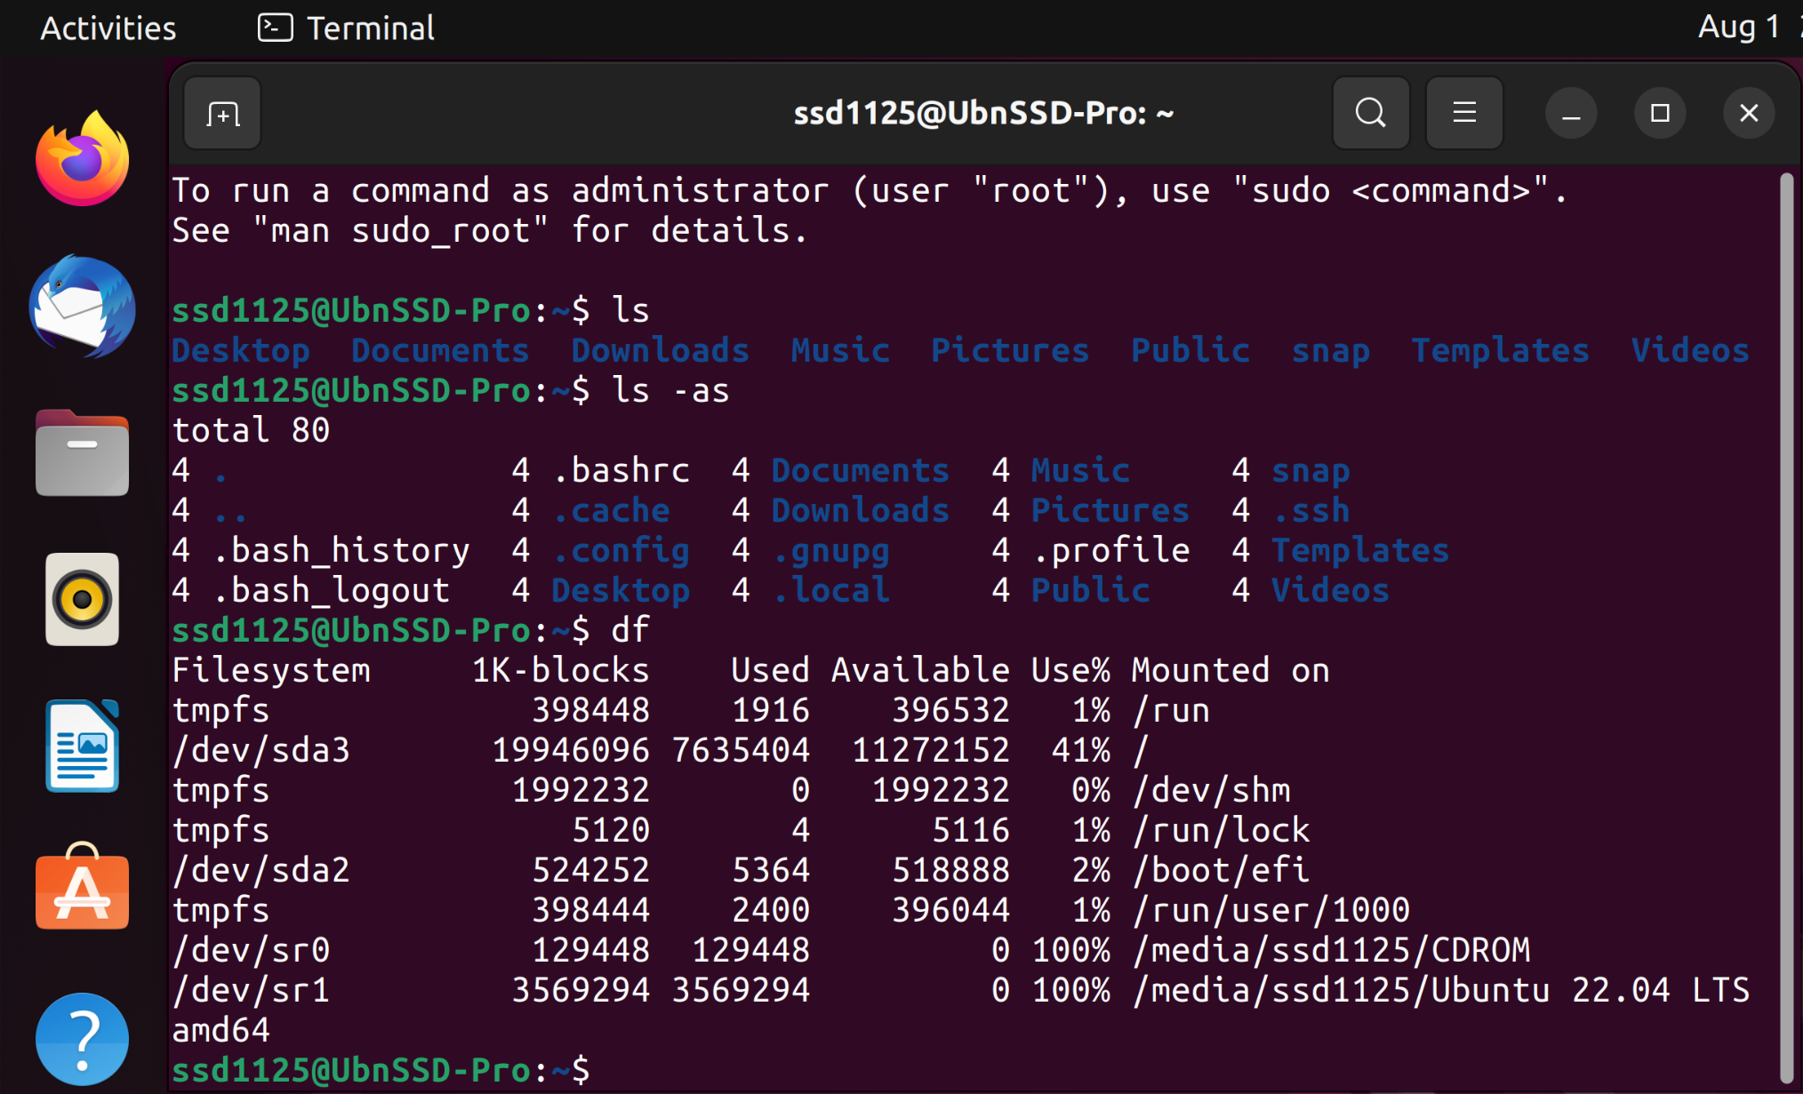**df:** (display filesystem) command displays information about the disk space usage of all mounted filesystems.

**free** – Displays the amount of free space available on the system.

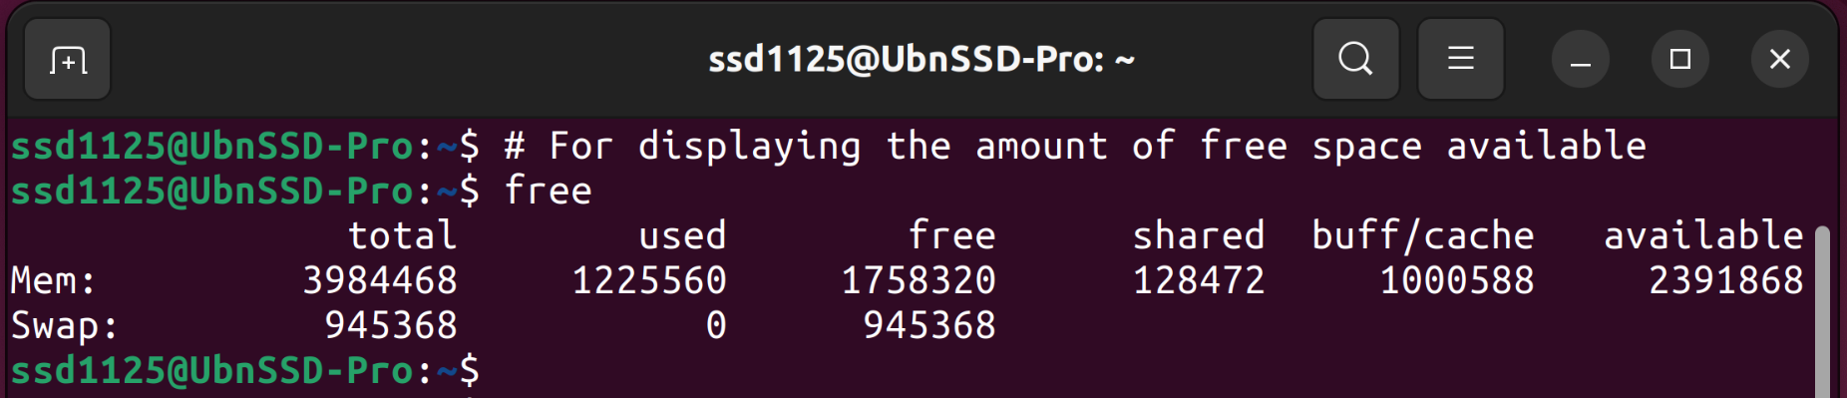

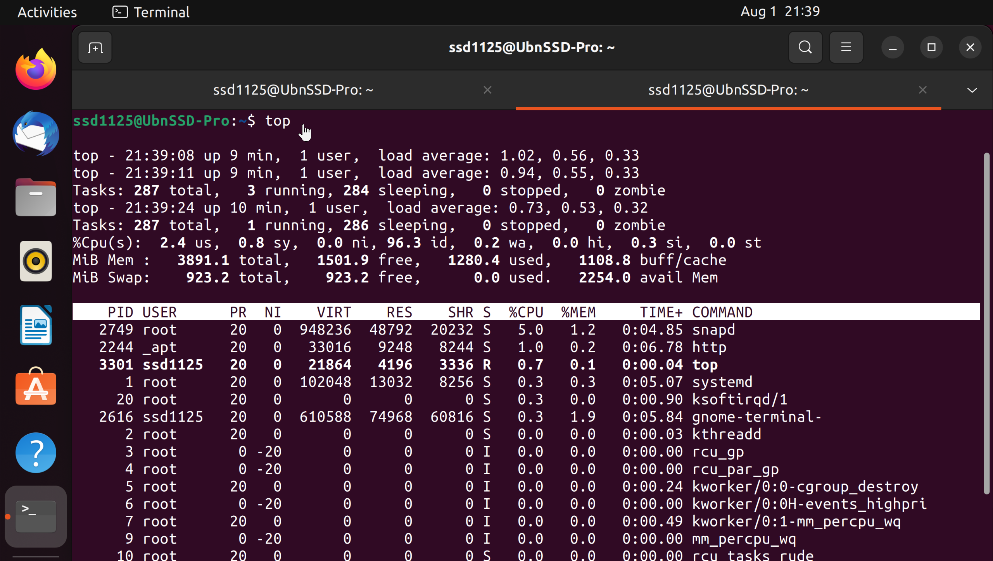

**top** – Displays the processes using the most system resources at any given time. “q” can be used to exit.

**man**

**man** command displays a “manual page”. Manual pages are usually very detailed, and it’s recommended that you read the man pages for any command you are unfamiliar with. Some uses are :

* man man – Provides information about the manual itself.
* man intro – Displays a brief introduction to Linux commands.

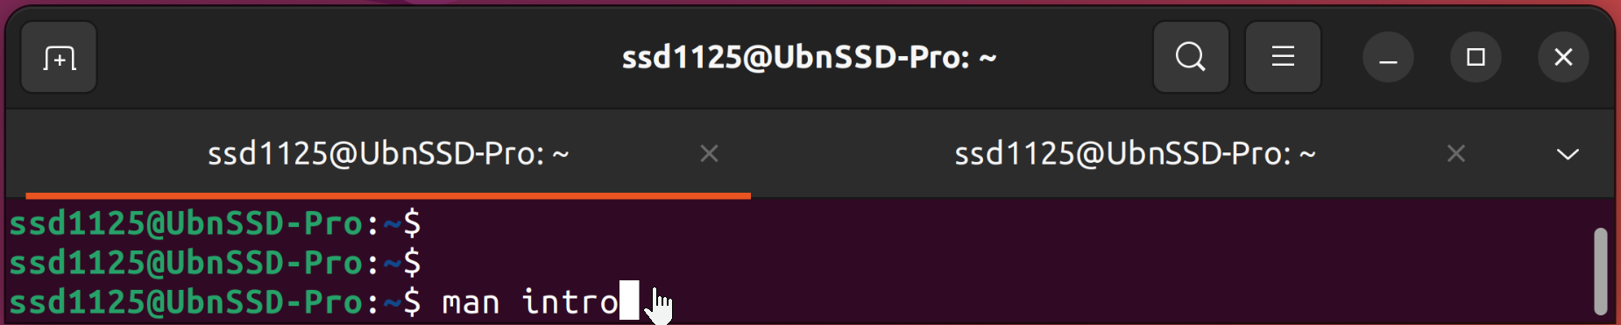

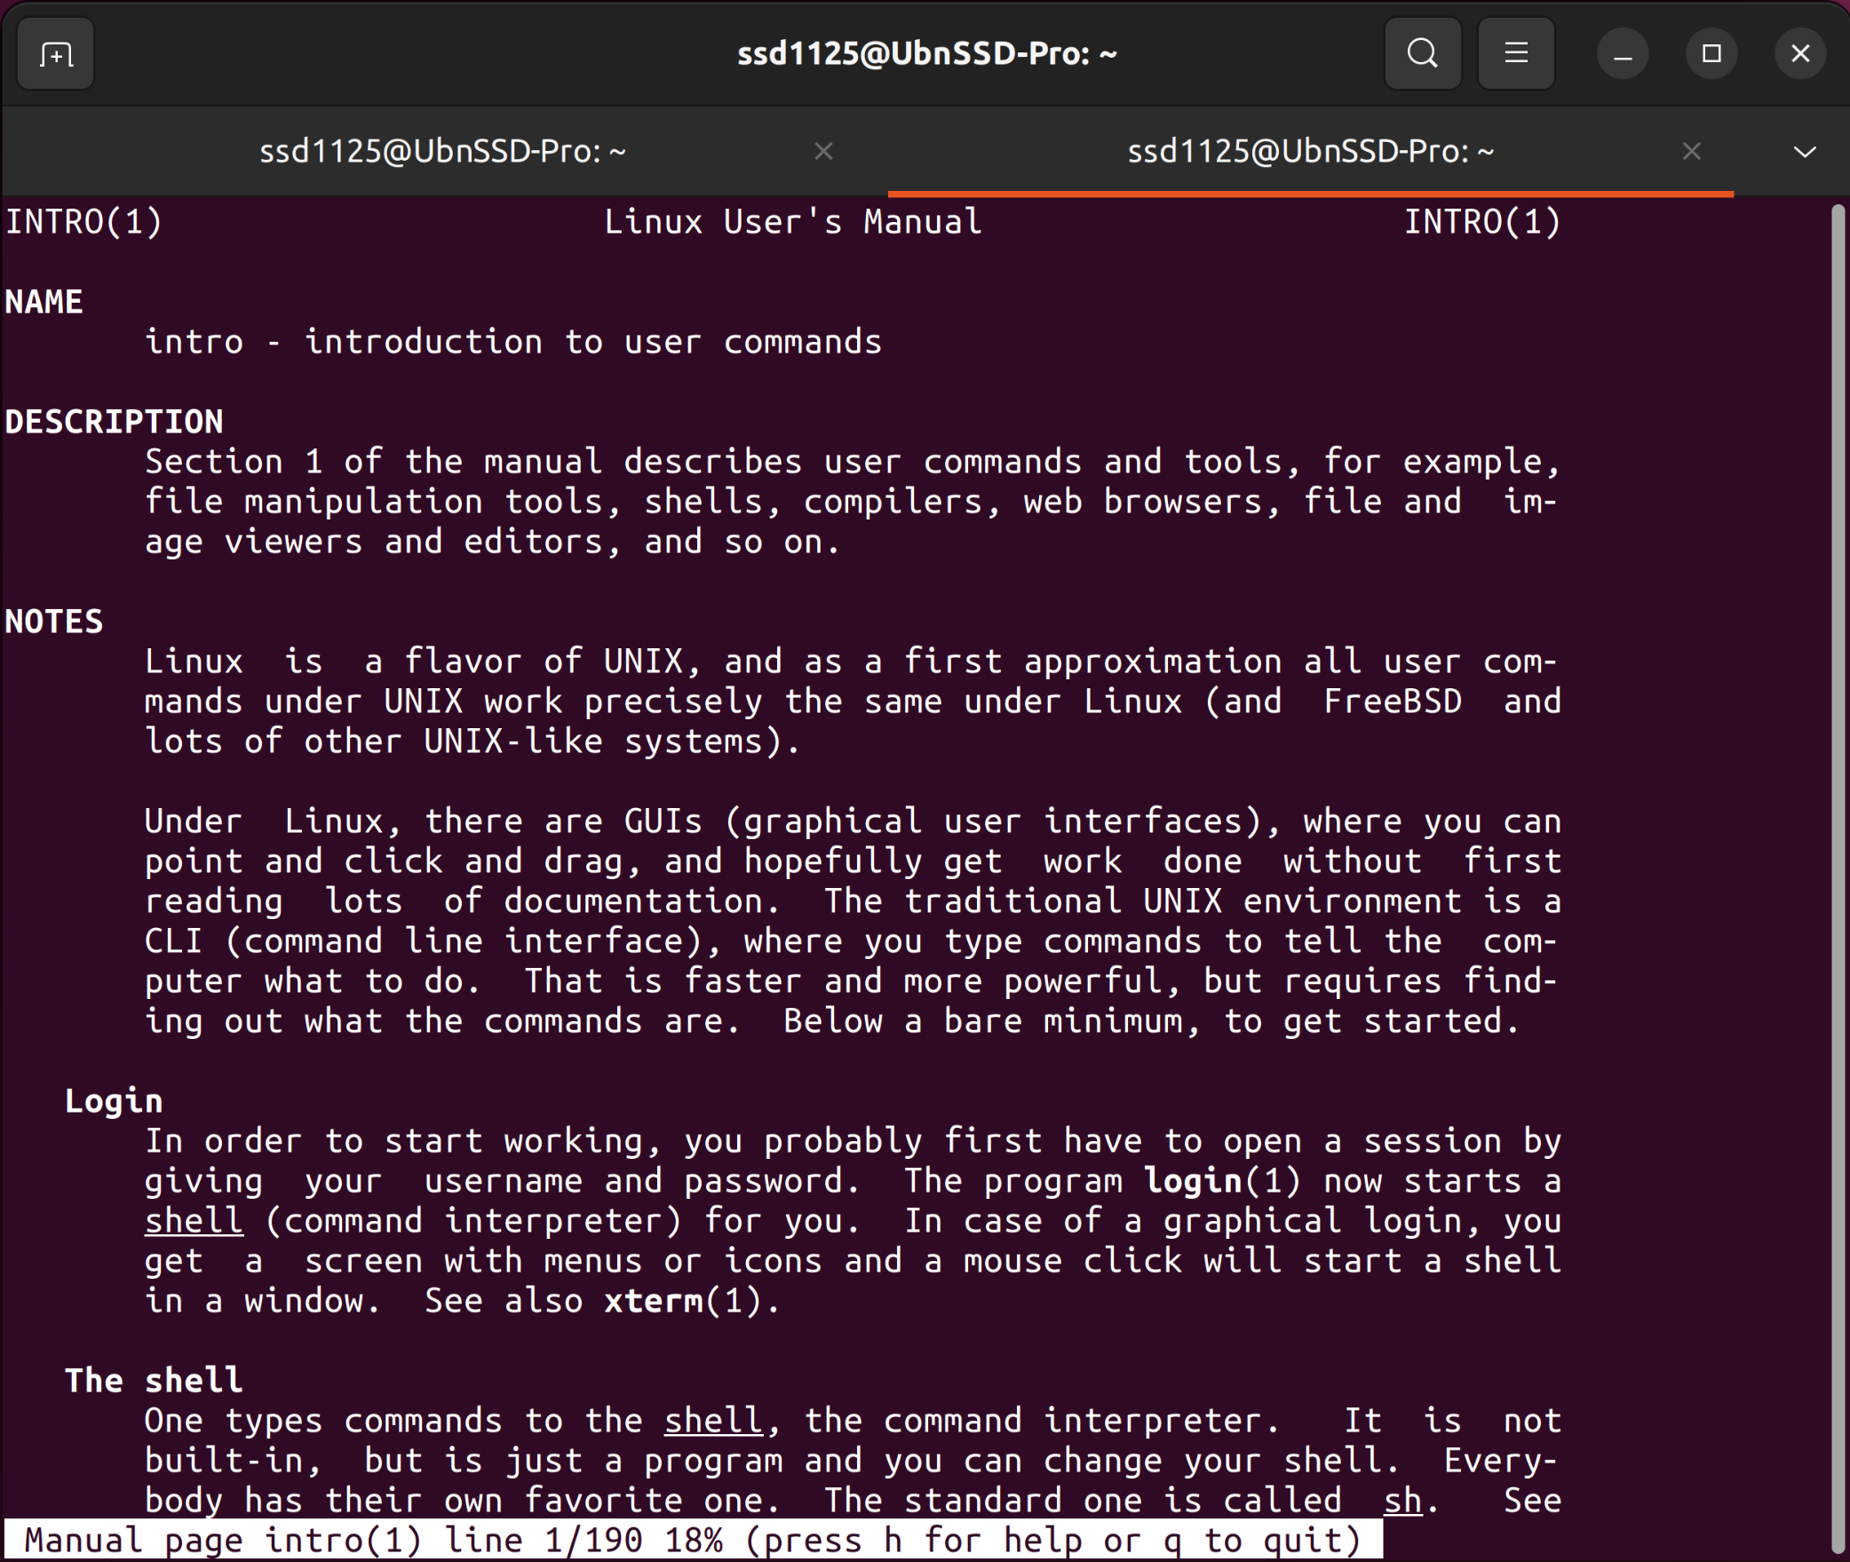

**whatis** command shows a brief description of what is the functionality of specific built-in Linux command.

whatis <command>

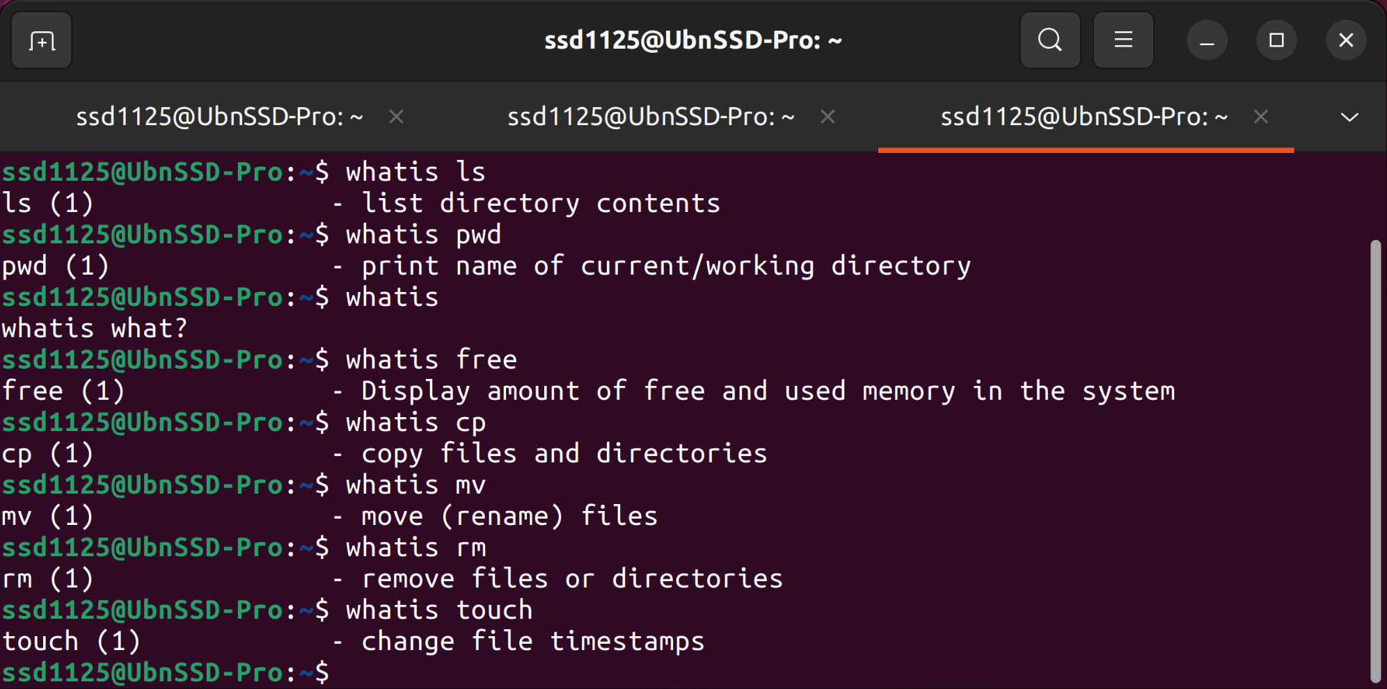

**history** command displays all of your previous commands up to the history limit.

